Project Report

Department of Computer Science and Engineering

University at Buffalo, Buffalo, NY 14260

**Team**: Desireddy Sai Sankeerthana Vamshi Jamalpur

[saisanke@buffalo.edu](mailto:saisanke@buffalo.edu) [vamshija@buffalo.edu](mailto:vamshija@buffalo.edu)

**Problem Statement :**

Each and everyday thousands of products are sold daily in the stores. The retails owners purchase a wide range of products to be sold at their stores and they must be cost-effective so that they can maximize their profits. Purchasing unwanted items or items that are not in demand or buying items in bulk and not being able to sell them profitably would incur a huge loss to their stores. Which pushes the retailers to take wrong decisions and invest in more unwanted things which might lead the store to fall into debt. Hence a retailer must have a better understanding of his customers demands and of the products he is purchasing to increase the sales. To solve this problem, we have come up with a solution that will predict the sales of the products with the help of the factors that are affecting these sales which gives us a better idea on how to increase the profits.

**POTENTIAL OF THE PROJECT**: This prediction of sales is based on various factors such as the geographical location of the store and the type of products sold in the store etc, which helps the outlet owners to get a good analysis of the products that will increase the sales. This forecasting helps the business owners to know what kind of products are getting more sales based on their location. And helps new markets, outlets find out more about products that would help them earn more profits. It also helps different types of outlet owners to know what kind of products to be purchased based on their outlet size.

**Data Source:**

In this project, we will be analysing Big Mart sales to find out sales prediction of each product at particular outlets and address the prediction of sales of respective products available in particular outlets

We have collected dataset from Kaggle. Reference for data source https://www.kaggle.com/datasets/shivan118/big-mart-sales-prediction-datasets

**DATA CLEANING/PREPROCESSING**

* Step-1 Loading the dataset into our environment.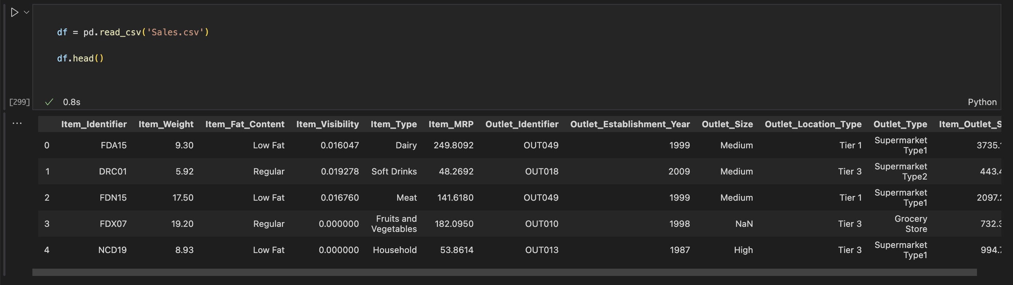
* Step-2 Now we will be Checking the type of data present in the file like whether it is numerical data or object data etc.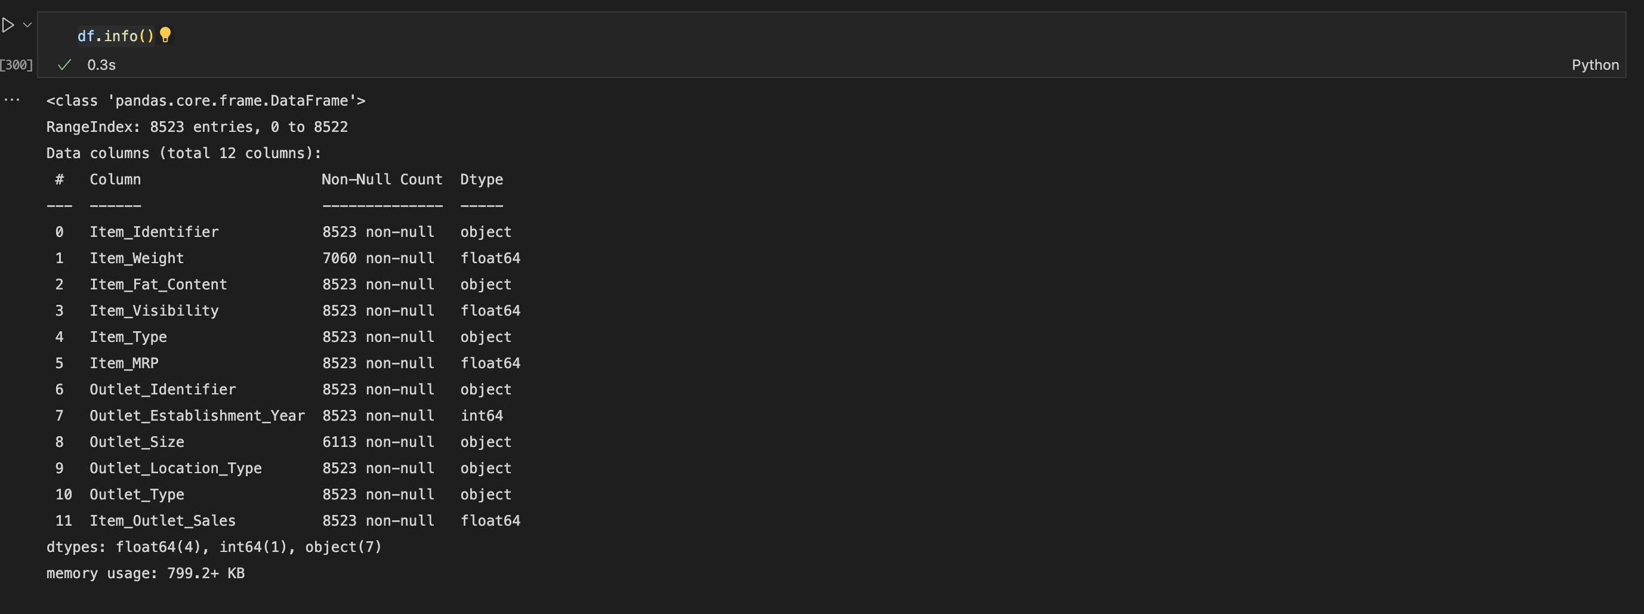

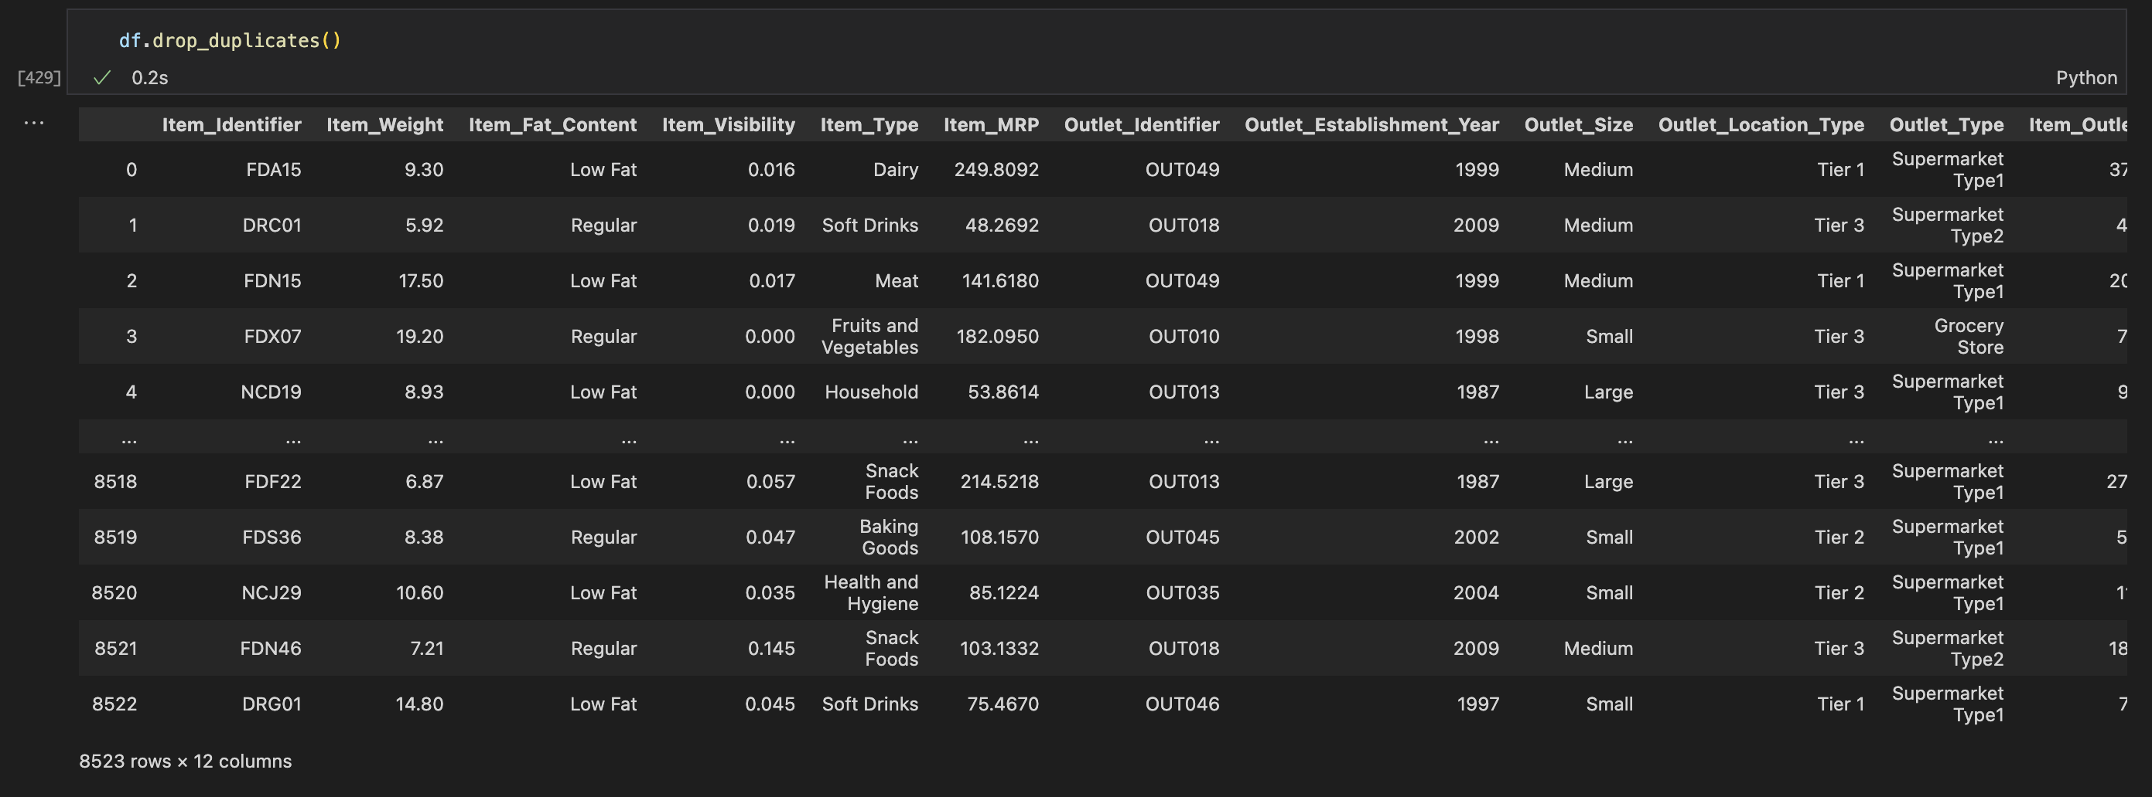

* Step-3 Drop the duplicate values present in our data.
* Step-4 We have to Check whether there are any missing or null values present in our data to avoid any inconsistencies and loss of data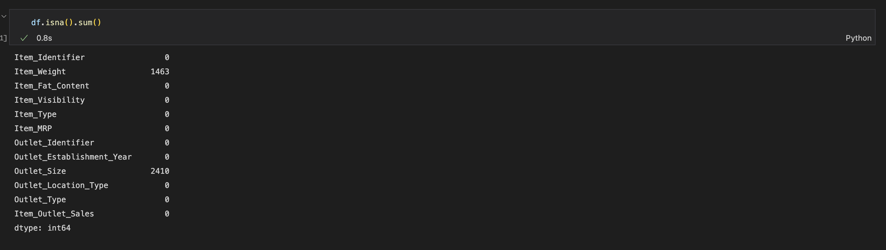
* Step-5 Now we can observe that there are two columns which have null values present.
* Step-6: Replacing the null values for the column Item Weight with the mean of that column . This method is useful when we have numeric data.We will Check whether the null values are filled with the mean or not.
* Step-7 Now we have the column Outlet_Size as we can observe there is a relation between the Outlet size and the outlet type ,so we cannot directly take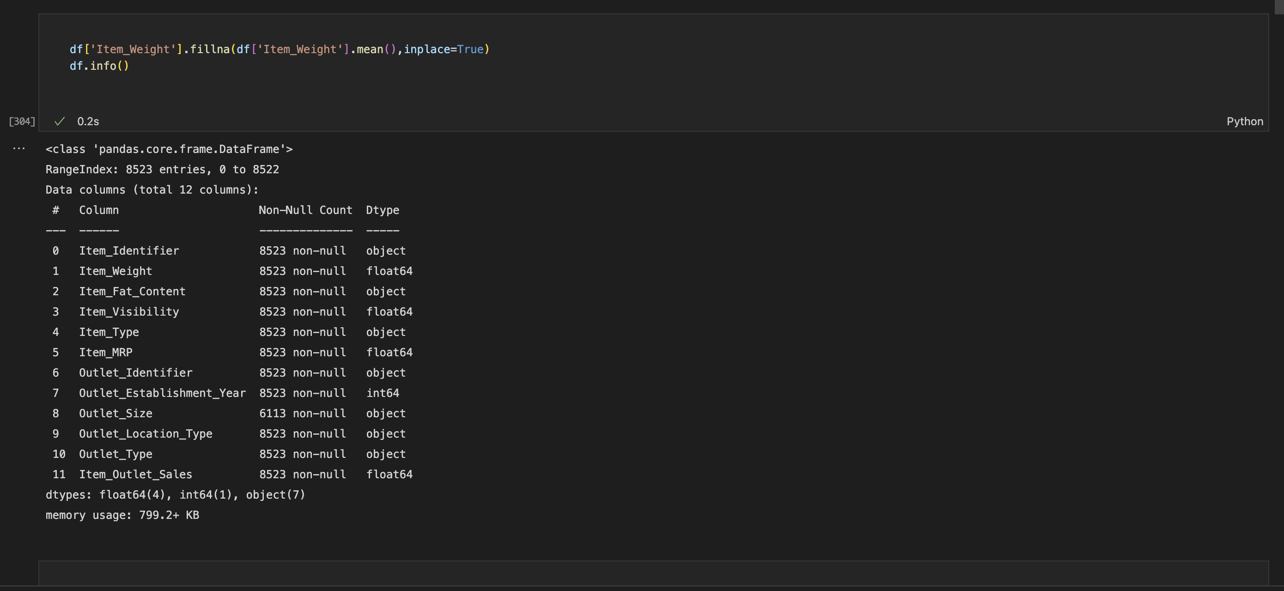 the mode of the all outlet size, based on which outlet type has more occurrence we will take the mode.

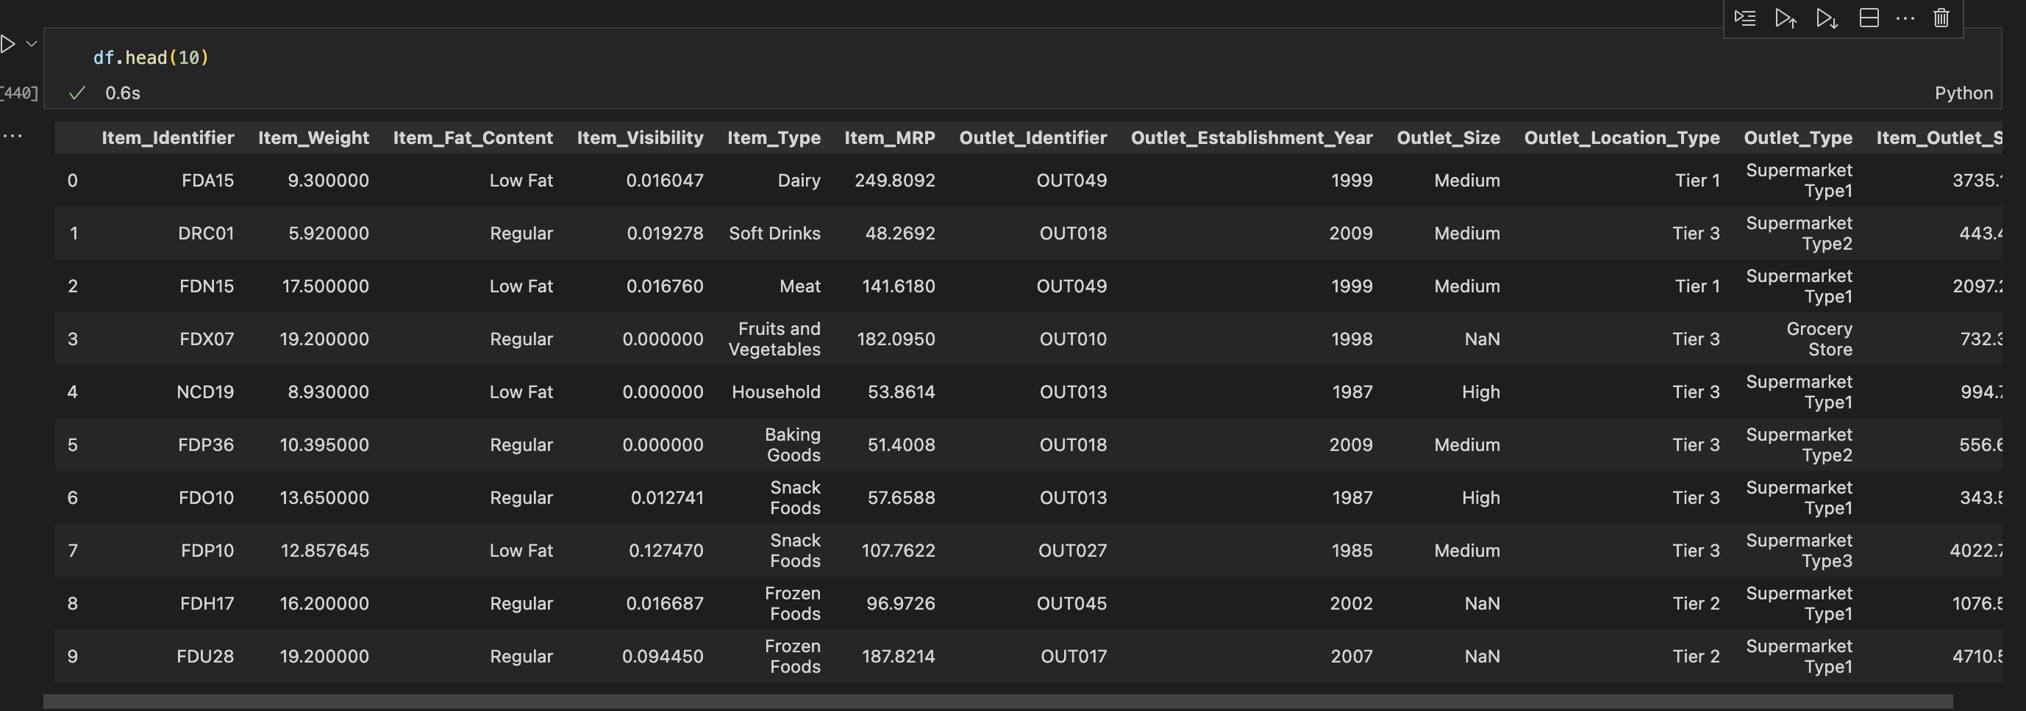

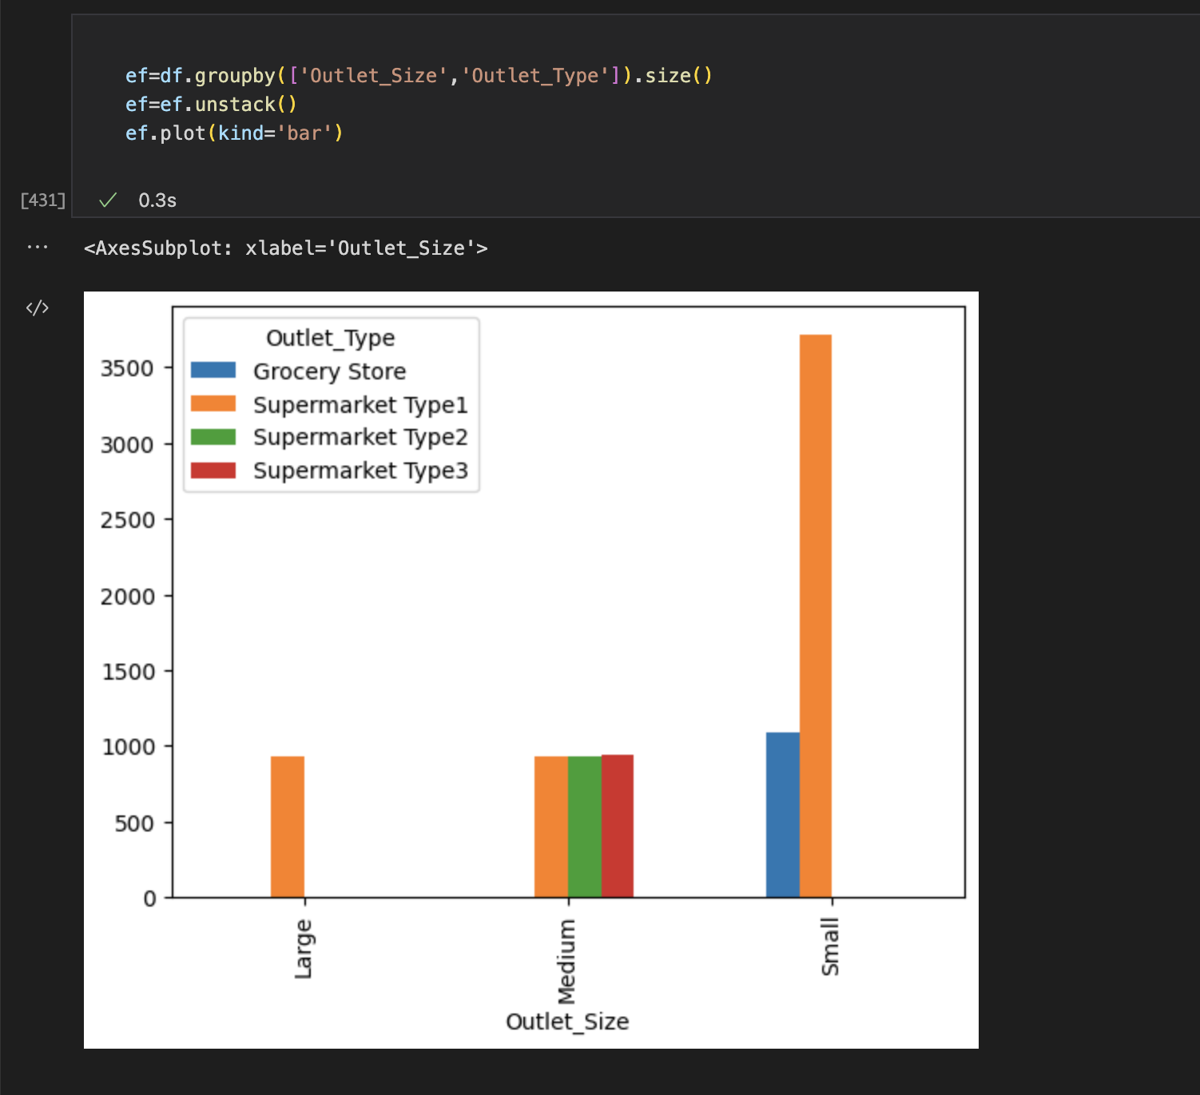

After taking mode and replacing them: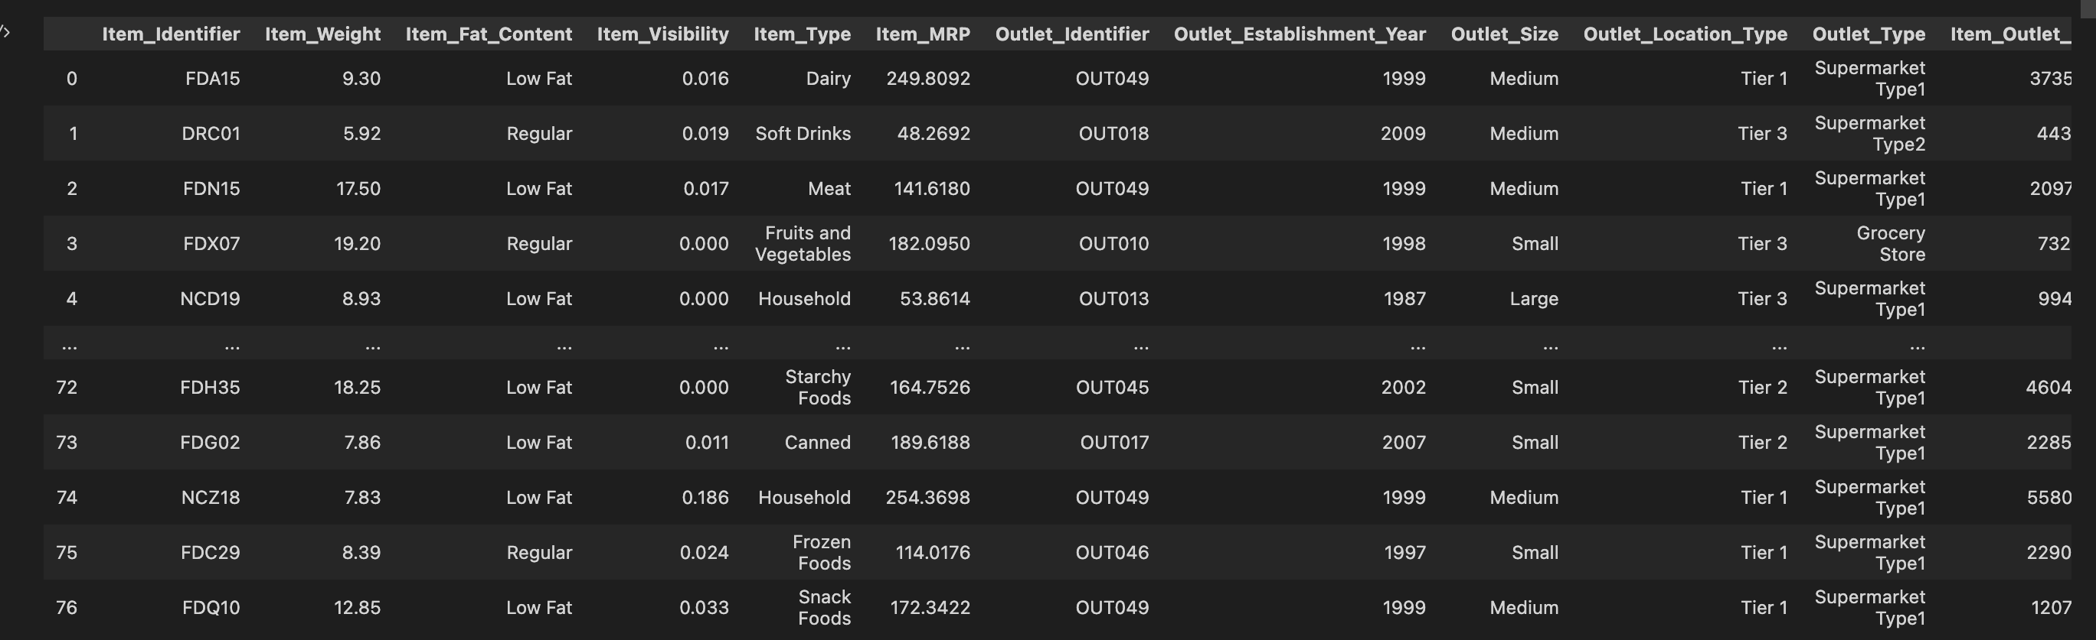

* Step-8 : In the Item_Fat_Content attribute we have the four variables with Low Fat, LF, lf, reg,Regular. Replace corresponding names with the Low Fat and Regular
* Step-9 : In the Outlet_Size we have high, Medium, small. Changing the size from high To Large
* Step-10: Changing the respective object type to Category type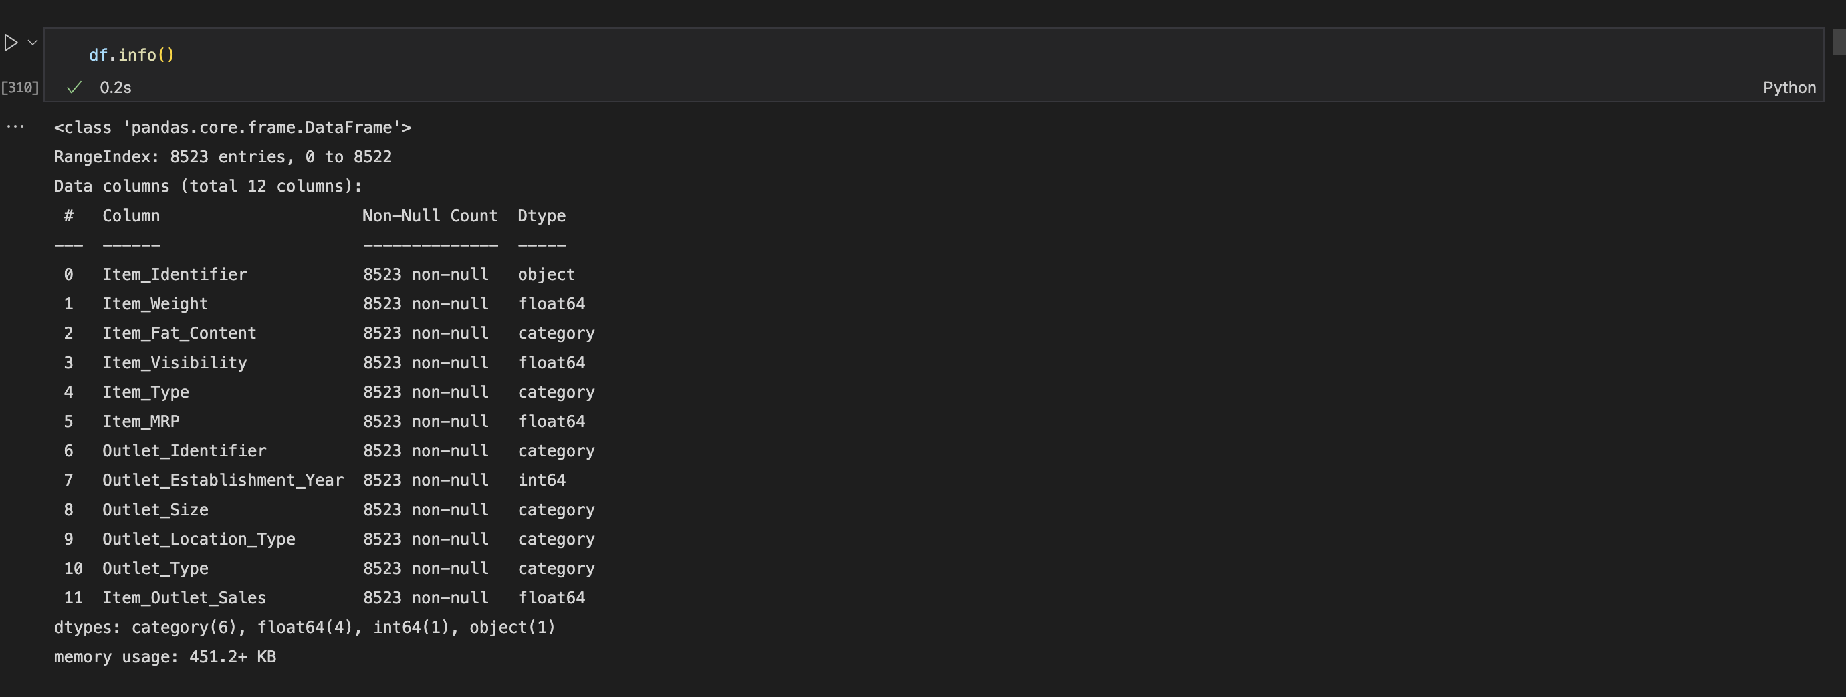
* Step-11: Rounding the Item Weight to 2 decimal values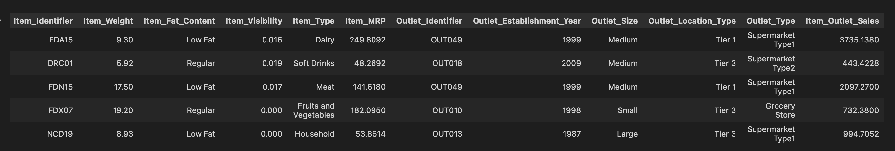
* Step-12 :Rounding the Item visibility to 3 decimal values
* Step- 13: Changing the categorical values to numerical values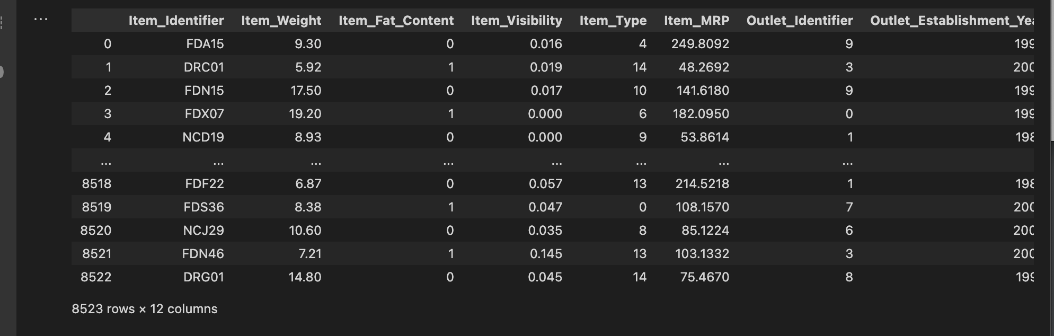
* Step-14: One hot encoding to Outlet Size as outlet size depends on the outlet_type so we are encoding the outlet size.

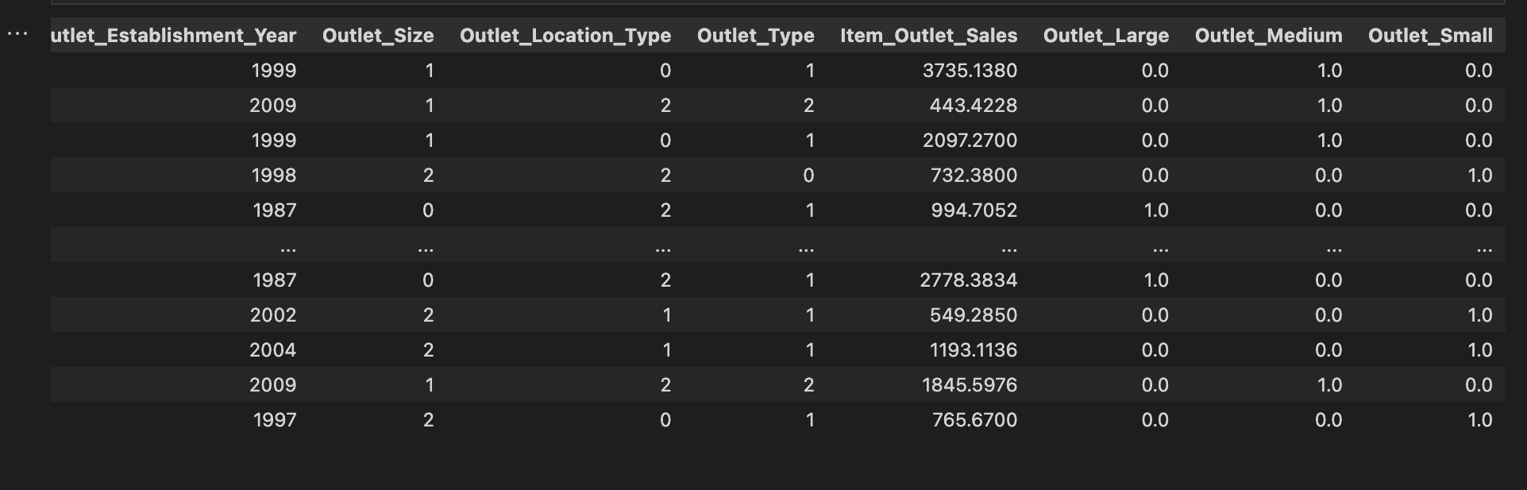

* Step-15 :Check if there are any outliers ,if found using the IQR change it to the range.

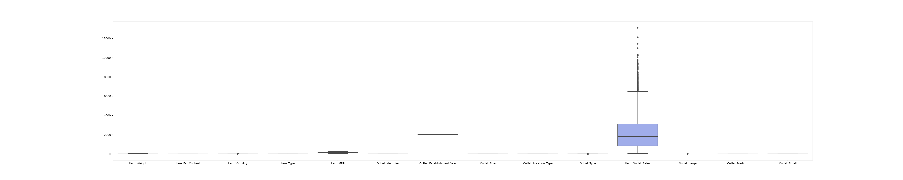

After removing outliers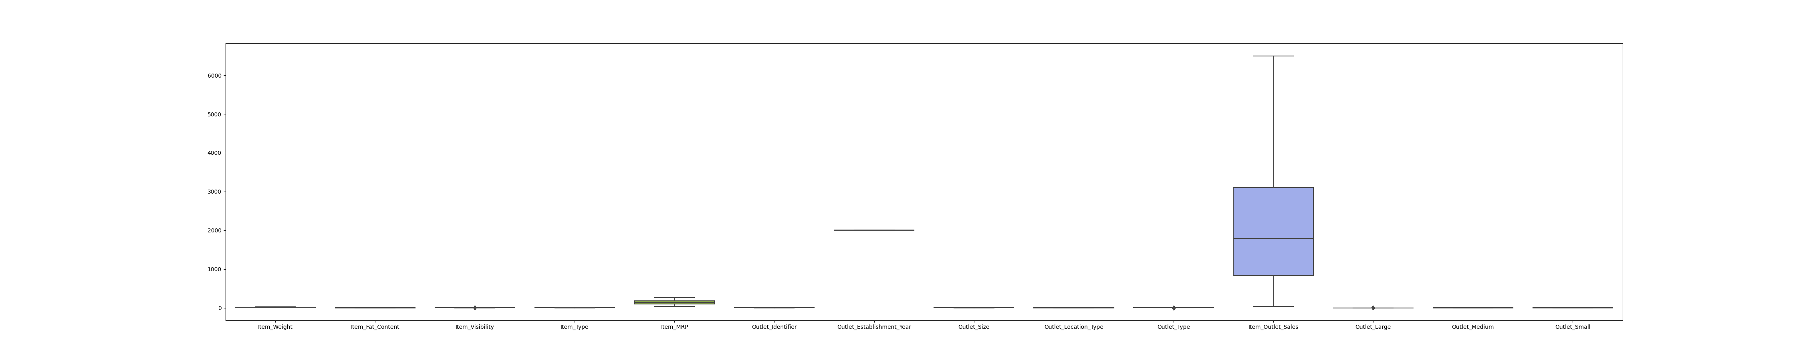

* Step-16: Normalising the non numerical variables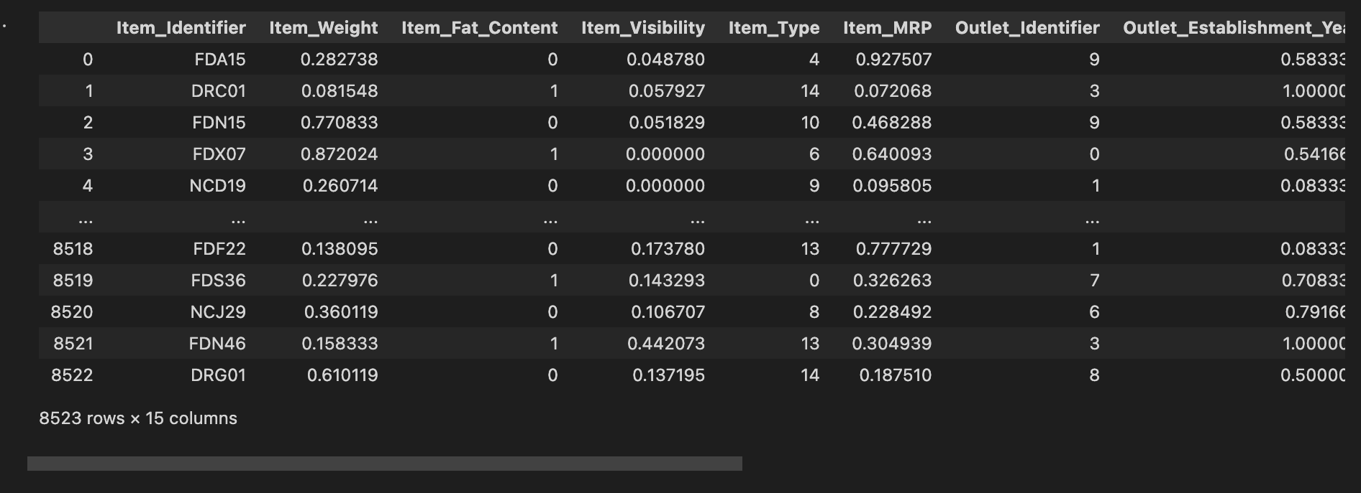

**EDA(EXPLORATORY DATA ANALYSIS):**

* Step-1: Describe the data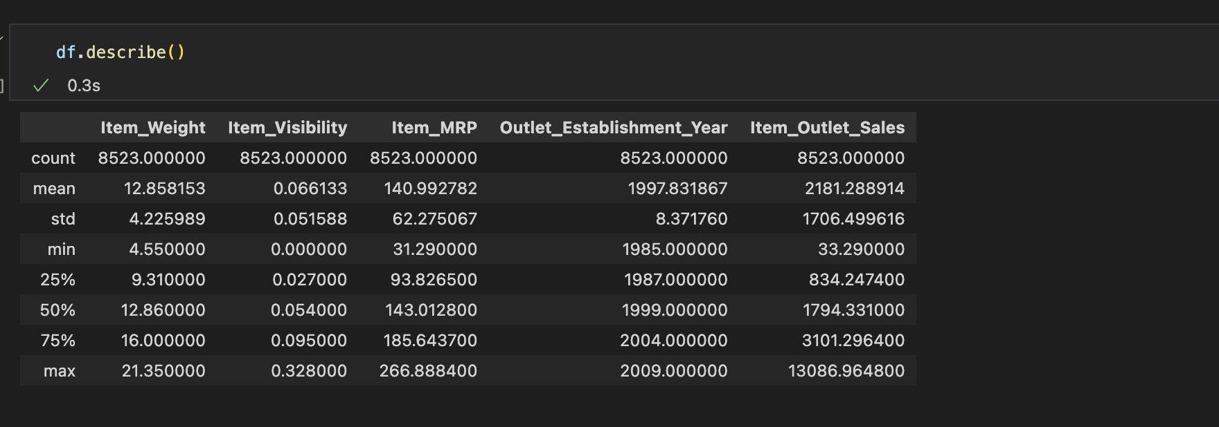
* Step-2: Check if there are any null values

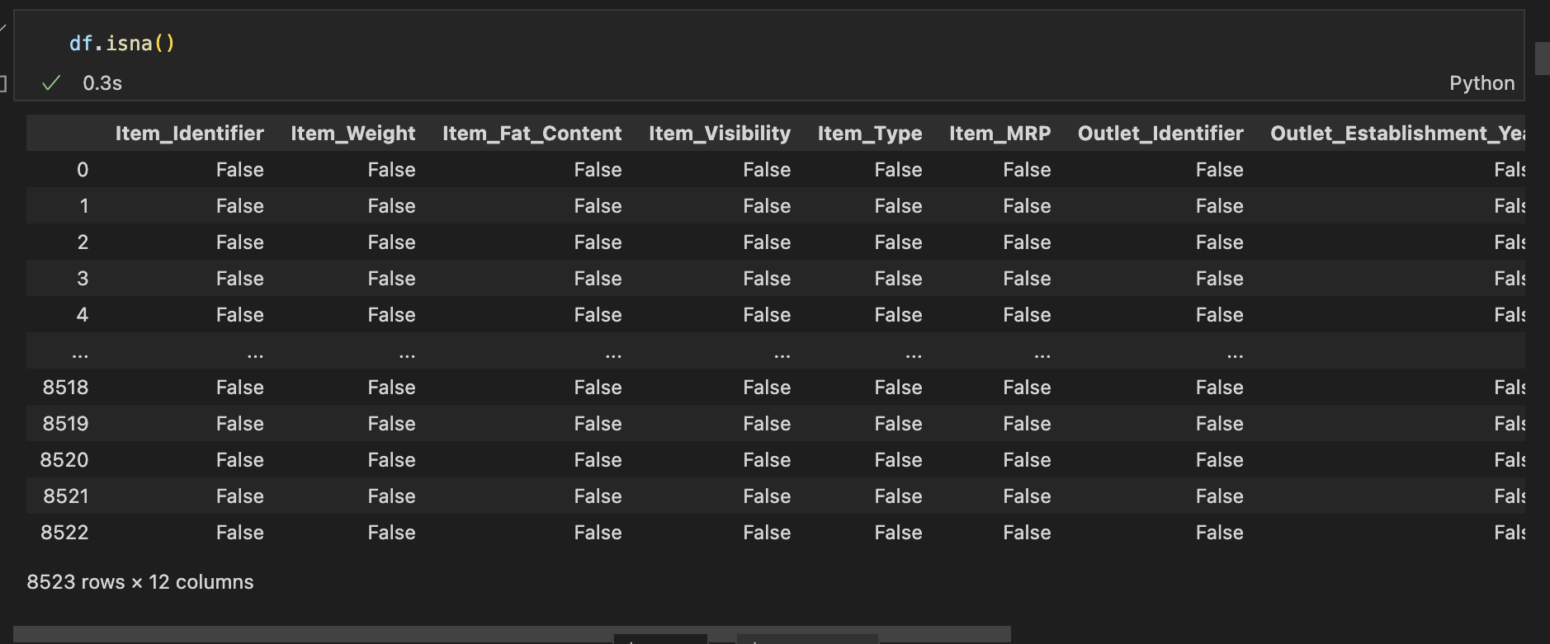

* Step-3: Check the co-relation between the numerical data

Image

As we can see the co-relation between the numerical data.the negative integers represents there is less/no relation between the features, positive integers represents there is good/high relation between the features that can impact the other one.As we can see there is strong correlation between the mrp and the item sales.

ImageStep:4 Plot all the numerical attributes.(pair plot)

From the given graph we can see Item_outlet goes on increasing with Item_mrp. And Item_weight has similar correlation with Item_outlet_sales

**UNIVARIATE ANALYSIS:**Image

**Observation:**

In the given bar graph, all the weights lie in between the 5 and 20 and most of them are lying in the range of 12.5

Image

**Observation:**

In the given bar graph, all the items visibility lie in between the 0 and 0.30 and most of them are lying in the range 0.20-0.50 .It states us that most of the products are less visible in a big mart.

Image

**Observation:**

By analysing the graph ,most of products are fruits and vegetables which consists of near to 14 % of whole data and sea food is the least selling in the count.

Image

**Observation:**

By analysing the graph, most of them are the small stores which is nearly (4800), 56% . And the least from the large stores which is (<900) or 9%.

Image

**Observation**:By analysing the graph, most of the products are in Low fat which is nearly (>5000) 58% and 35% of the products are low fat.

Image

**Observation:**

By analysing the graph, most of the outlets are from the supermarket type 1 with more than 62%(>5000) , and the least from the supermarket type 2 with 9%.

Image

**Observation:**

Most of them come from the tier-3 location which consists of 39% of them and less number of sells came from the tier-1 which is 25%.

Image

**Observation:**

Most of them are in the range of 100-200, and less number of products in the range of 70.and most of the products have the price in range of 100-20

Image

**Observation:**

Most of outlets are established in the year of 1995-200 and 1985-1990.and no outlets are established between 1990-1995.

**BIVARIATE ANALYSIS:**

Image

**Observation:**

By analysing the graph, most of the sales came from the fruits and vegetables, dairy and household and least with the others and hard drinks.

Image

**Observation:** By analysing the graph, we can see most of the sales came from the supermarket type 3 and less sales from the grocery store.

Image

**Observation:** By analyzing the graph, we can see most of the sales came from the tier 3 location and less sales from the tier 1.

Image

**Observation**:By analysing the graph , we can see most of the sales came from the medium size store. And less sales from the large store.

**MULTIVARIATE ANALYSIS:**

Image

**Observation:**

By analyzing the graph we can see most of the sales came from the medium size store which was located in the tier-3 location, and less number of sales came from the Small sized store from the tier-3 location.

Image

**Observation:**

By analyzing the graph we can see that most of the sales came from the tier-3 and the type of the supermarket is supermarket type-3.From grocery store tier-3 There are less number of sales.